
Disk Array System
DS600-G20

产品型号系统
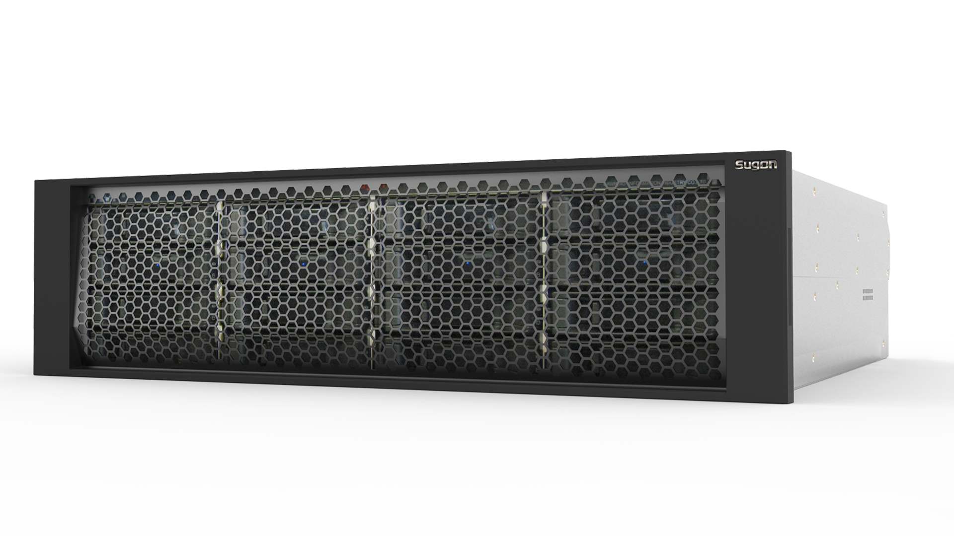

Information construction has been extensively integrated into the business systems of different industries. Elasticity of these systems is closely associated with the flexibility of the IT architecture. Operation efficiency of the IT system affects efficiency of these business systems to much extent. Customers are facing the challenge of quick data quantity growth and more complicated business due to diversified business models, which requires higher performance, capacity and reliability of the storage system. The high-performance FC storage and IP storage products with high price/performance ratio in the above difficult cases are gradually becoming the main stream on the market.
DS600-G20 is a FC and IP integrated storage product presented by Sugon, which is designed with the advanced idea and architecture, includes the hot plug dual controller, and 8Gb FC,1Gb/10Gb GbE interface, provides multiple advanced data processing and transmission technologies such as SAN and NAS function, multi-core processor and Flash cache protection, and ensures high reliability, high performance and strong scalability of the system. The system is compatible to convenient IP storage environment (iSCSI/NAS), realizes FC connection, iSCSI connection and NAS connection, and effectively fuses multiple protocols.

Features:
- Advanced system architecture and high-performance storage platform
- Overall high-availability design, ensuring data reliability
- Multi-protocol access supports, effective integration with FC/iSCSI/NAS
- Complete disk security policy

Overview
- Construct a high-performance storage platform by using plentiful advanced technologies in the industry and large-capacity cache expansion;
- Support large-capacity cache and adopt intelligent cache management mechanism and cache protection mechanism leading in the industry in order to improve cache efficiency and data security;
- Support multiple host interfaces such as 1GbE,10GbE and 8Gb FC to satisfy application of customer’s complicated environment;
- Support NAS protocol and SAN protocol;
- Support high-performance SSD and SAS disks and large-capacity SATA disks and perfect integrate data hot point with SSD disk;
- Realize fine management of disks via cell management to improve tolerance to disk failures and improve efficiency of data reconstruction several times;
- Extremely simplify configuration and management via a friendly Chinese and English interface and guide configuration manner;
- Facilitate configuration management and maintenance via the enhanced intelligent interface.

Technical features

Functional features
Advantage
Complete disk security control mechanism

In normal system operation, the disk detection module periodically conducts media inspection, thus to perceive the disk bad blocks earlier than the application system and initiate the appropriate restoration measures in advance, thus to realize initiative prevention, rapid restoration and reduced misjudgments of disk failures from the aspects of disk detection, faults restoration and troubleshooting. The outage caused by diks failures is reduced by 80%.

Advanced redundant architecture design

Full redundant architecture design, cable-free unit connection, reliable long-term system operation is guaranteed.
Controller chassis, controllers, power, fans and other main components are of modular design, supports hot swaps and online replacement of single components. In case of any failure in individual components, rapid faults isolation and components replacement can be realized, thus to avoid serious impacts on the entire system.

Flexible expandability

The system cabinet is able to accommodate 16 disks, flexible disk expansion can be realized through the high-speed SAS expansion channel, maximum 6 expansion cabinets can be connected, the disk quantity can be expanded to 112, the expansion cabinet supports various disk specifications, such as SSD, SAS and SATA, combing with the data characteristics of different business systems, users can realize tiered storage of data.

Advanced PRAID technology

The advanced PRAID technology divides the RAID space into different units and implements resource management on such units. When there is any data bad blocks in the diks, only the unit where the data bad blocks exist will be affected, the system can reconstruct data against this unit, while other data in the disk will not be affected, this not only reduces the impact extent of bad blocks on system data, but also improves the data reconstruction efficiency by several times.

Powerful Flash caching technology

The traditional lithium battery configuration protection is arranged; meanwhile, the caching data protection policy is added with Flash Cache configuration. When the disk array is turned off and in power failures, Cache data is protected through BBU to prevent lost, if BBU is not powered, data will be transferred into Flash Cache. There is no power-down time limits.

Intuitive unified management functions

Provides complete GUI and CLI management interfaces whose operation is easy and convenient.
Through using appropriate guiding interface, the administrator can set the application types, space size and other information through only clicking on the mouse, thus to finish resource allocations easily, supports different warning mechanism, such as EventLog, indicator light warning, console alarms, buzzer alarm, SNMP warning, warning message and so on.

Specifications
Technical specification for disk array main cabinet
Specification | DS600-G20 (single-controller configuration) | DS600-G20 (dual-controller configuration)
Controller | Hot plug and single controller | Hot plug, dual-redundancy controller and Active－Active operation mode
Processor | 64bit multi-core processor
Cache | 2GB-16GB | 4GB-32GB
Cache battery protection | Lithium battery
Flash Cache protection modulus | Standard permanent storage and backup unit and no outage time restriction
Per controller host channel | 4 1Gb ISCSI host interface  4 1Gb ISCSI host interface, 2 8Gb FC host interfaces/2 10Gb ISCSI host interfaces
Disk channel | SAS 4x disk expansion interface
RAID grade | 0, 1, 3, 5, 6, 10, 50 and 60
Capacity expansion mode | RAID level change
Hot spare disk | Intelligent global hot-spare disk
NAS feature
Protocol supported | CIFS (MAC, Windows), NFS (Linux/Unix)
Domain supported | Microsoft ADS
Sharing disk supported | Privilege management, quota management and online expansion
Physical features
Maximum disk number supported | Maximum 6 connected JBOD and 112 extended disks
Single frame disk density | 16
Disk capacity supported | 2TB, 3TB, 4TB（7200 RPM）3.5 inch SATA / NL SAS；  300GB, 600G B, 900G B and 1200G B（10K RPM）2.5-inch SAS；  120GB, 240GB and 480GB 2.5-inch SSD；
Dimension | Standard 3U 19-inch frame (131x447x507mm)
Power, fans | 2+1 redundant power supplies, redundant fans and online replacement
Weight (net) | 20.1kg (no disk)
Noise | 55dB -75dB
Management features
Management interface | Sugon disk array management software
Faults alarm | Interface alarm, sound and light alarm, E-mail alarm and SNMP
Log | Support real-time display, import and export of alarm log
System compatibility
Fiber devices supported | QLogic, Emulex and Brocade etc.
Operating system supported | Support OS such as Windows Server 2003/2008，Red Hat Linux AS 5.6/6.5，SUSE Linux Enterprise Server 11.3 and Vmware ESX ;
Specification for operation and power supply
Temperature | Operating: 5~35℃; Non-operating: -40~60℃
Relative humidity: | Operation: 10%~90%, Non-operating: 5%~95%
Power supply | 100V－240V, 47Hz—63Hz, 460W and 2+1 redundant power

Technical specification for disk array expansion cabinet
Technical specification | DS600-G20 single control expansion cabinet | DS600-G20 dual-control expansion cabinet
Interface | 2 SAS 4x expansion interfaces | 4 SAS 4x interfaces
Disk slots number | 16
Power and fans | Dual redundant heat dissipation modules and dual-redundant power modules
Operation and power supply specification
Temperature | 10℃－40℃
Relative humidity | 8％－80％（non condensing environment）
Power supply | 100V－240V, 47Hz—63Hz, 460W and 2+1 redundant power
Advanced function
Volume copy | Support, configured
Disk energy saving | Support, configured
Intelligent interface | Support, configured
Intelligent switch | Support, configured

For more information:
Please visit official Sugon website: www.sugon.com or dial the customer service hot line: 400-810-0466/800-810-0466.
You can also contact Sugon branches distributed throughout the state, for contact information, please log in the official website of Sugon.
Sugon reserves the right modify the product specifications or other product information (including, but not limited to weights, appearance, dimensions or other physical elements) without any further notification.
Any alternation to information involved in the document caused by products upgrading or other causes, no additional notification will be provided. All product graphics involved in the document shall be subject to the physical products.

